Bahria University,

Karachi Campus



LAB EXPERIMENT NO.

4

LIST OF TASKS

|  |  |
| --- | --- |
| TASK NO | OBJECTIVE |
| 1 | Where (to which window) is the output data displayed? |
| 2 | Write down the address of the first instruction of the program (see the text window)? |
| 3 | Write down the values of $a0 and $v0 after execution in Register window? |
| 4 | Write an assembly program that print char. |

Submitted On:

15/10/19

(Date: DD/MM/YY)

**TASK NO.1:** Where (to which window) is the output data displayed?

**SOLUTION:**

RUN I/O window present at the bottom of Editor displays the output data.

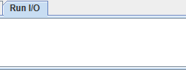

**TASK NO.2:** Write down the address of the first instruction of the program (see the text window)?

**SOLUTION:**

li $v0, 5 #read integer

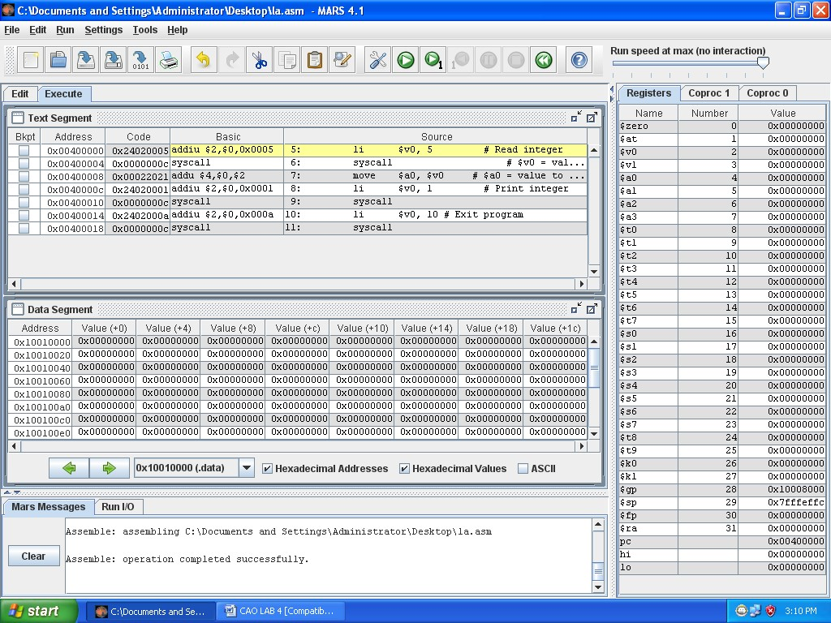Address: 0x 00400000

**TASK NO.3:** Write down the values of $a0 and $v0 after execution in Register window?

**SOLUTION:**

Value of $v0 = 0x0000000a

Value of $a0 = 0x00000003

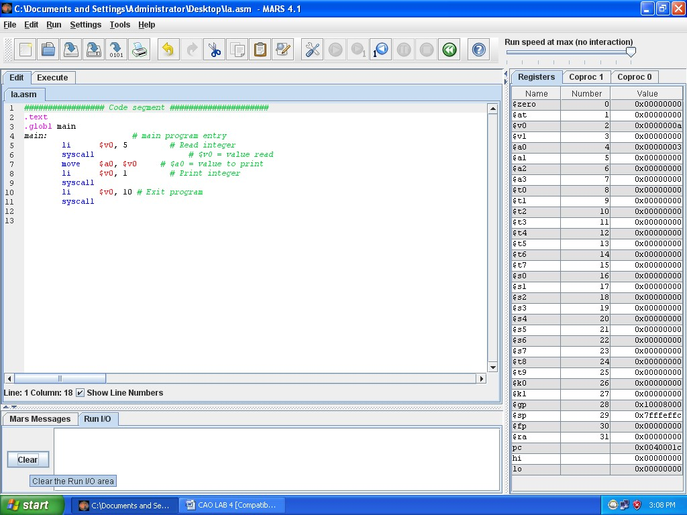

**TASK NO.4:** Write an assembly program that print char.

**SOLUTION:**

CODE:

**.data**

char:.byte 'M'

**.text**

li $v0,4

la $a0,char

syscall

OUTPUT:

